Matthew J. Ellis, B.Sc., M.B., B.Chir., Ph.D., FRCP
2019 Susan G. Komen®
Brinker Award for Scientific Distinction in Clinical Research
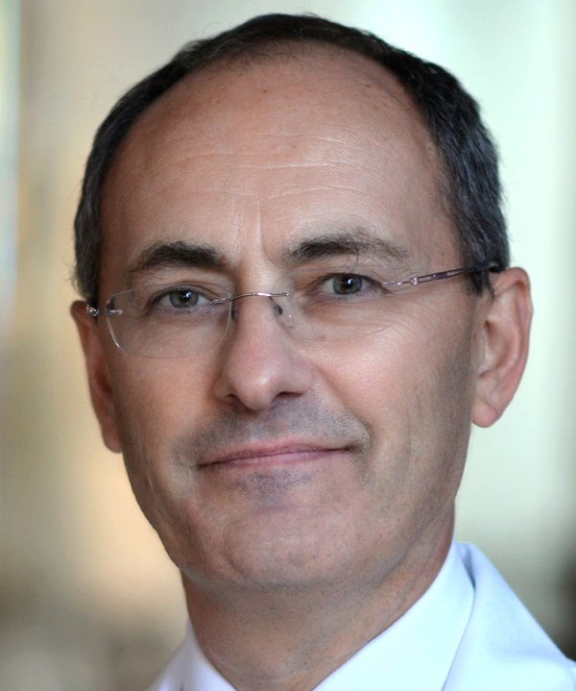
Matthew J. Ellis, B.Sc., M.B., B.Chir., Ph.D., FRCP is being honored for his seminal contributions in understanding the genomics of breast cancer and translating this knowledge to the clinic in order to improve the efficacy of breast cancer treatment. His translational approaches to studying the genomic aspects of breast cancer, drug resistance and biomarkers for breast cancer prognosis, coupled with his pioneering research in the pre-surgical treatment of breast cancer, has led to the identification of tumor markers and implementation of new treatment regimens that are being increasingly used worldwide.

A clinician-scientist, Dr. Ellis has devoted his career to bridging the gap between basic research and patient care. His research has used cutting-edge/state-of-the-art technology to gain a better overall understanding of how genetic aberrations in breast cancer cells influence disease characteristics and therapeutic response. Over the last 20 years, Dr. Ellis led a series of clinical trials that established standard of care, using breast-conserving therapy, for postmenopausal women with ER+ HER2- stage 2 and 3 disease. He also recognized the extraordinary scientific opportunity these neoadjuvant (pre-surgical) clinical trials offered and championed their use (and collection of biospecimens therein) to explore mechanisms of drug resistance in breast cancer and discover biomarkers of drug action.

Dr. Ellis conducted seminal genome sequencing studies that identified mutations in TP53 and NF1 as mediators for poor outcomes and mutations in MAP3K1 and GATA3 as mediators of more favorable, indolent disease. He also discovered links between single strand DNA repair defects and endocrine therapy resistance, and ESR1 translocation as a cause for endocrine therapy resistance and metastasis. Several laboratories are now trying to develop therapeutic approaches targeted to these genomic events. Dr. Ellis also pioneered research into the clinical relevance of activating mutations in HER2 and was instrumental in identifying HER2 mutations that could serve as therapeutic targets.

Dr. Ellis has had a long-standing interest in developing prognostic assays for ER+ breast cancer. He led the team that developed the PAM50-based, multigene prognostic test for breast cancer that is now an FDA-approved test available worldwide. His research helped establish the value of Ki67 as a surrogate endpoint to monitor response to neoadjuvant endocrine therapy and led to the development of the Preoperative Endocrine Prognostic Index (PEPI), which is undergoing prospective validation in the ALTERNATE trial, as a tool to de-escalate chemotherapy use in patients who respond well to the neoadjuvant endocrine therapy.

Driven by the principle that the cure for breast cancer will come from the study of the patients themselves as traditional preclinical approaches do not capture the full heterogeneity of the disease, Dr. Ellis pioneered studies that established the value of patient derived xenografts (PDX) for breast cancer research. Using PDX and whole genome sequencing, he and his team showed how the breast cancer genome is remodeled during metastasis. During this work they identified the first chromosomal translocation involving ESR1 that is associated with endocrine therapy resistance and metastasis. Preclinical studies using PDX models are providing evidence that may inform the design of clinical trials using rational combinations of targeted therapies for breast cancer. The team is now conducting mass spectrometry-based analyses to deepen our understanding of the connections between genome and proteome in breast cancer.

Dr. Ellis earned his medical degree from the University of Cambridge in England in 1984 and continued his clinical training at the Royal College of Physicians. He received a PhD in molecular biology from the University of London in 1992, before completing a medical oncology fellowship at Georgetown University Hospital in Washington, D.C. He remained at the Georgetown faculty until 2000, when he moved to Duke University Medical Center, serving as an Associate Professor of Medicine, Division of Hematology/Oncology until 2003. He then took a position at Washington University School of Medicine in St. Louis, MO, and was the Anheuser Busch Endowed Chair of Medical Oncology, Professor of Medicine and Section Head of Medical Oncology until 2014. Dr. Ellis is currently Professor of Medicine and Molecular and Cellular Biology, Director of the Lester and Sue Smith Breast Center, and Associate Director for Precision Medicine at the Dan L. Duncan Cancer Center, Baylor College of Medicine in Houston, TX.

Dr. Ellis has designed and led institutional and cooperative group clinical trials, conducted laboratory studies focused on molecular pharmacology and endocrine therapy resistance, designed FDA-approved molecular diagnostics for breast cancer and headed multidisciplinary teams of clinicians, bench scientists, statisticians and technologists to focus on difficult problems in breast oncology and the identification of the basic processes driving the disease. His patient focused, biology-driven translational approach to breast cancer research has resulted in significant advances that are paving the way for more personalized treatments for breast cancer and will tangibly touch the lives of breast cancer patients around the world for years to come.

