

Promise Action
Corporate Challenge
2011 Affiliate Handbook

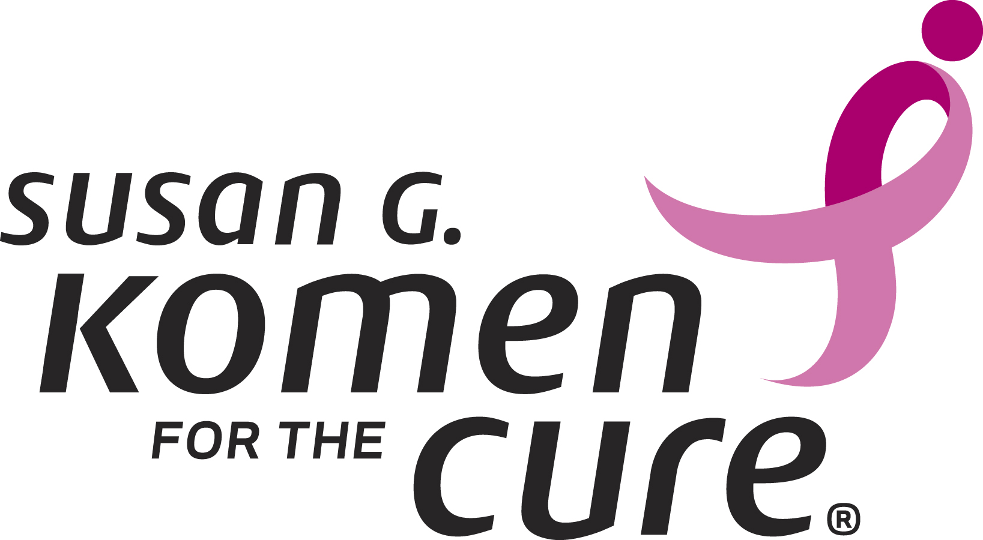

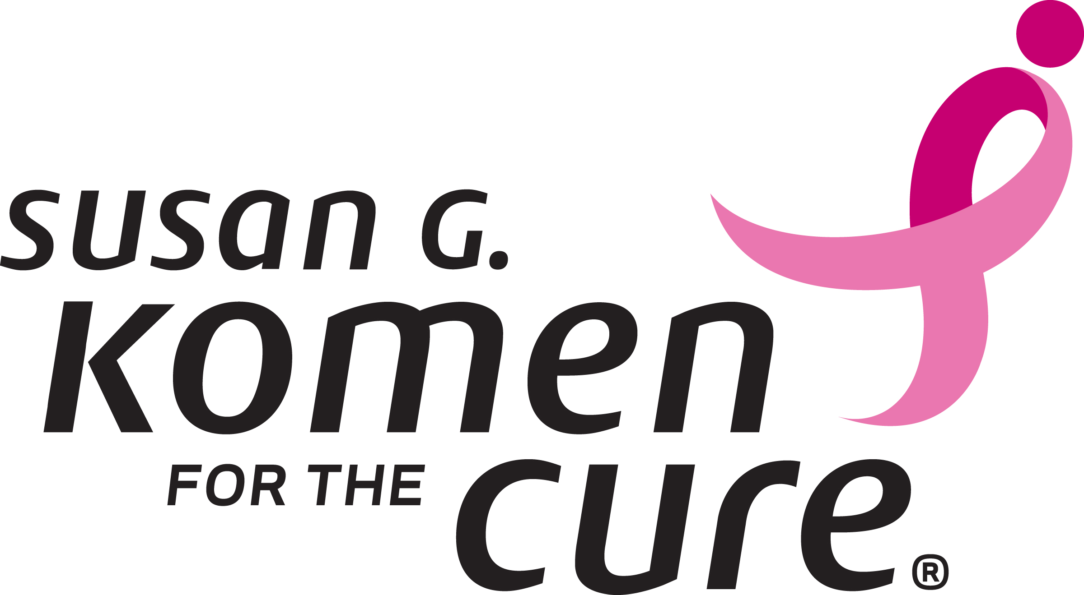
Table of Contents
Welcome Letter 3
Executive Summary 4
Promise Action Corporate Challenge Campaign Goals. 4
Initiative. 4
Key Messages 4
Campaign Details 5
Affiliate Activation 5
Measurement 5
Timing 6
Campaign Benefits for Participating Companies 6
Promotional Tools 7
Contact 7

Welcome Letter
Dear Affiliates,
Thank you for joining the Promise Action Corporate Challenge campaign, a broad-based employee outreach initiative. This handbook is designed to help you reach out to companies that you have relationships with and ask them to take the necessary action in ensuring the women and families they support are empowered to take control of their health and utilize preventative health services.
As an organization that has been fighting back against breast cancer since 1982, we were shocked to learn that less than 50 percent of women over the age of 40 with health insurance receive the recommended annual mammogram screening. Therefore, this October one of our key target audiences remains working women who have the tools to get screened but continue to fail in taking the action to do so. By joining the Promise Action Corporate Challenge campaign we are asking our supporters to take action on komen.org/promiseaction by committing to do the following:
- Get Screened – Utilize Komen’s mammography appointment reminder tool to remember to schedule a mammography screening and ensure attendance.
- Educate – Empower working women to take charge of their breast health and understand the risks that arise without taking action.
- Spread the Word – One in eight women will be diagnosed with breast cancer in her lifetime, ask campaign supporters to spread the word and tell seven people they care about to take action.
The goal of this campaign is to continue to increase compliance with our breast cancer screening recommendations and build awareness that early detection is the key to survival.
This is an unprecedented opportunity to engage your supporters in the fight against breast cancer and ensure that lives are saved.
Thank you again for your leadership in achieving a world without breast cancer. Together, we will make our efforts this October a milestone in the global breast cancer movement.
Sincerely,
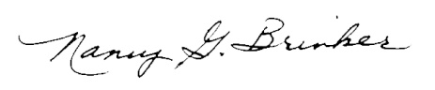
Ambassador Nancy G. Brinker
Founder and CEO
Susan G. Komen for the Cure®

Executive Summary
After three decades of progress in gaining public awareness and support for the breast cancer movement, we are at risk of losing ground as people become complacent, budget cuts put important programs at risk and women fail, for a wide variety of reasons, to get life-saving breast screenings and mammograms. According to a recent study, more than 50 percent of women with health insurance did not get the recommended annual mammogram. This is unacceptable to us because we know that early detection is a key factor in a woman’s chance of surviving breast cancer. During October’s Breast Cancer Awareness Month 2011, we need “Less Talk. More Action.” In our role as the global leader of the breast cancer movement, Susan G. Komen for the Cure® is launching a series of public outreach initiatives that seek to galvanize our base of supporters while catalyzing action at both the national and global level in this important fight. Our primary goal is to increase mammography screening rates and the early detection of breast cancer by asking the public to take meaningful action.

Promise Action Corporate Challenge Campaign Goals: To increase screening rates and promote the awareness of early detection through increased compliance with screening recommendations and outreach among corporations and government organizations.

Initiative: Beginning September, 2011, Ambassador Nancy Brinker will launch the Promise Action campaign, a far-reaching challenge to governments, businesses, individuals, communities and our own community of survivors to take specific and measurable actions that result in the early diagnosis and best care and treatment for anyone, anywhere, who receives a breast cancer diagnosis. An integrated marketing plan is being developed to support these efforts to include advertising, social media, public relations, events, community and corporate partners.

Key Messages: Our platform will include calls for action in three key areas: personal empowerment, advocacy and education. As the founder and inspiration of the global breast cancer movement Ambassador Brinker will issue a call for America to stop talking and start acting.
- We cannot lose ground. Early screening is the key. It is not okay that less than 50% of women with health insurance, over the age of 40 are not getting an annual mammogram. Call to action: Women must get screened. Families must urge the women in their lives to get screened. Large employers and government representatives will play a key role in helping us reach working women and urge screenings.
- Everyone should know their risk. We will not allow complacency in regards to breast health. Everyone should know the risk they take in failing to get screened. Call to action: Educate yourself. We must grow and strengthen a culture that values breast health awareness and take our life-saving recommendations and guidelines seriously.
- Let your voice be heard. Love the pink, fear the pink. We need your help as we fight to protect the rights of breast cancer patients and survivors so they have access to the care they need. Everyone has a role to play in the effort to protect federal and state funding for research and screening programs. Call to action: Sign up as a Komen advocate.

Campaign Details
This Campaign is about promoting action to get screened and raise awareness that early detection saves lives. The Promise Action campaign asks employers and employees to take action in the fight against breast cancer by:
- Making an appointment to get screened
- Opting-in to receive information about breast health and wellness
- Educating yourself
- Spreading the word
- Making an impact

Affiliate Activation
Provide information to company supporters about the importance of getting screened and understanding breast health. On Affiliate Corner, resources will be provided to help you begin your outreach and provide your supporting companies with educational materials to share with their employees. You may also choose to promote the campaign on your website by highlighting companies in your service area who have taken the challenge and link to the national campaign link.

Measurement
To help us achieve our goal of increasing screening rates we will need supporting data. We will need your help in tracking the number of your supporters that commit to participating in the campaign and the number of CEO’s that pledge to encourage their employees to take action and get screened. We would also like to compare the 2011 mammogram rates to the 2012 mammogram rates in different cities and then report back to companies so they can see how their participation in the campaign made an impact. Below is information regarding the average cost of treatment for all four stages of breast cancer, highlighting the significant impact companies can have on increasing the value of the U.S. health care system through early detection.
Average Costs of Treatment at 24 months*
*Study was based on Medicaid data from North Carolina and was published January 2011

- Stage I and some Stage II - $22,343
- Stage II and some Stage III - $41,005
- Metastatic or Stage IV - $117,033

Timing
Event | Date
Receipt of Promise Action Campaign Handbook | September 22, 2011
Promise Action Website Live | September 22, 2011
Promise Action Official Launch Date | October 3, 2011
Promise Action Measurements Reported to Komen | November 15, 2011

Campaign Benefits for Participating Companies
Screening benefits your employees and your company
- Saves lives
- Enhances the value of U.S. Healthcare

Komen will collaborate with company Human Relations team to:

- Establish employee roundtable discussions with attendance from Komen Leadership
- Provide education on different types of screening and treatments.
- Set-up a CEO roundtable with collaborating organizations in the campaign

Rewards:
- Corporate/CEO Campaign Honor Roll to be published in daily Komen publications.
- Recognition as a Promise Action Champion on our campaign website: www.komen.org/promiseaction. To add companies to the national website please submit names to Jessie Christianson at jchristianson@komen.org. You may also create your own site to list the local organizations that have joined as Champions of this Campaign and link to our national website so your supporters may view the full listing.
- PLEASE REMEMBER: Your Affiliate must receive permission from the corporation to publish its name on the Promise Action website and other recognition materials. Please forward this permission to jchristianson@komen.org once it is received. The permission can be a simple email from the coordinator for the company saying that Susan G. Komen for the Cure and its Affiliates have the right to recognize the company by name in any and all materials that list the companies participating in the program.

Promotional Tools
The following materials are options for participating companies to utilize in promoting the Promise Action campaign to their employees:
- Campaign talking points and sample emails for companies to share with their employees.
- Social media messaging for companies to post on their Facebook and Twitter accounts.
- Share our online understanding Breast Cancer Quiz to test breast cancer awareness among company employees: http://ww5.komen.org/BreastCancer/AboutBreastCancer.html.
- Contact local Affiliates to set-up a Pink Bag Lunch and Learn seminar at company headquarters.
- Komen will collaborate to establish employee roundtable discussions with Komen leadership.
- Ask companies to ensure a breast health seminar is held at the end of November to educate their employees about healthcare options during the time when health care insurance plans are renewed.

Contact

If you have any questions specific to the Promise Action campaign, please contact your ARM.

