Jane Visvader, Ph.D. &
Geoffrey Lindeman, MBBS, Ph.D.
2019 Susan G. Komen®
Brinker Award for Scientific Distinction in Basic Science

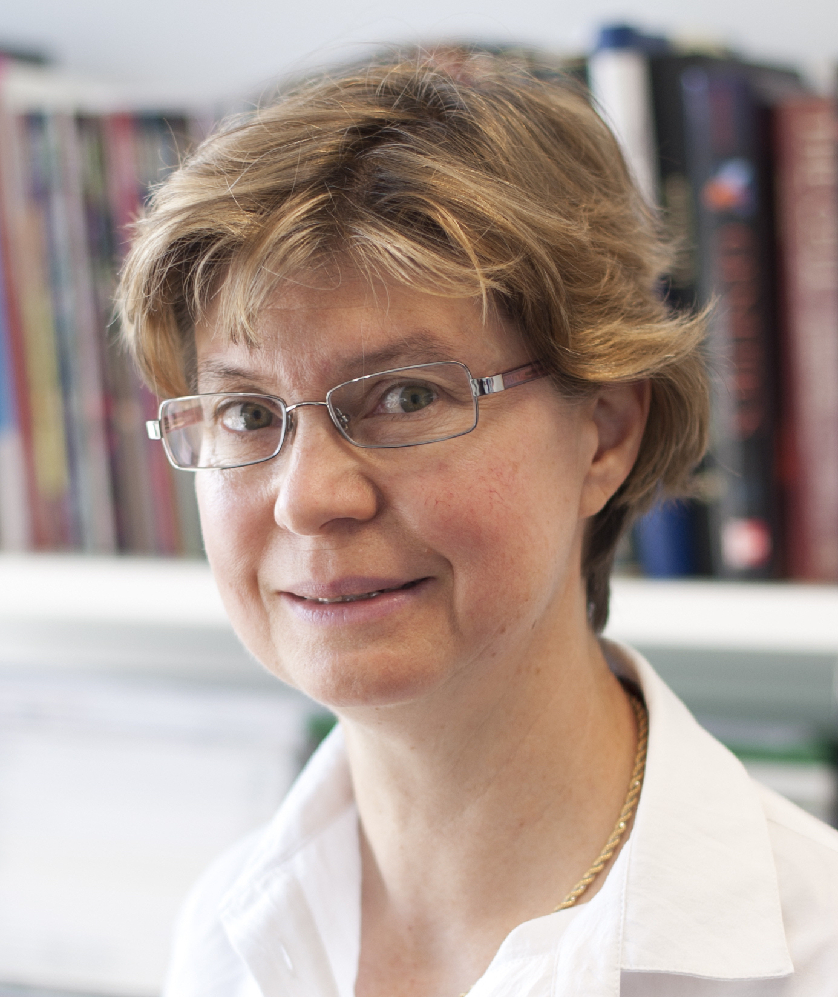
Jane Visvader, Ph.D, and Geoffrey Lindeman, MBBS, Ph.D., are being honored for their significant contributions to breast cancer research, which have been instrumental in advancing our understanding of how normal and cancerous cells develop in the breast. Their research has resulted in critical insights about the regulation of normal breast cell growth, breast cancer initiation and progression, including the identification of breast stem cells which give rise to normal breast tissue and the breast cells that are predisposed to becoming cancerous in women with BRCA1 gene mutations. Spurred by their unremitting drive for clinical impact, their work has contributed to the foundation for clinical studies of new strategies to treat and prevent breast cancer.

Over the past 20 years Dr. Visvader, a molecular and cellular biologist, and Dr. Lindeman, a medical oncologist, have focused their research on mammary gland biology and breast cancer. Their work aims to identify the cells and molecular pathways that lead to breast cancer with the goal of developing more effective biomarkers and targeted therapies. They have described the roles of BCL-2 and its family members and several transcriptional regulators in mammary gland development and breast cancer.

In a pivotal study in 2006, Drs. Visvader and Lindeman identified and successfully isolated mouse mammary stem cells and generated a functional mammary gland from a single stem cell. The discovery of the multipotent, self-renewing mammary stem cell by their group and others sparked a new field of research aimed at defining the role of these cells in the development of normal breast tissue and breast cancer. Stem cells were also shown to be highly responsive to ovarian hormones through paracrine signaling. The team went on to define several master regulators that orchestrate cell fate decisions in the mammary gland including Foxp1, Notch, Gata-3 and Ezh2, providing a framework for understanding mammary lineage commitment and differentiation. They demonstrated a similar cellular hierarchy in humans and described unique gene signatures for the different subpopulations of stem cells and progenitor cells in the human breast. Drs. Visvader and Lindeman were also the first to discover that luminal progenitor cells, rather than stem cells, are responsible for breast cancer in BRCA1 mutation carriers. More recent studies are interrogating the heterogeneity during normal mammary development and breast cancer using gene-targeted models, single cell technologies and 3D imaging platforms.

An important focus of Drs. Visvader and Lindeman’s laboratory is the transfer of research discoveries to the clinic to improve the treatment and prevention of breast cancer. Their finding that a targetable receptor called RANK is expressed on the surface of luminal progenitor cells in BRCA1 mutation carriers is now being studied in an international phase 3 breast cancer prevention trial, BRCA-P. Drs. Visvader and Lindeman have generated valuable preclinical models, including patient-derived xenograft (PDX) models and tumor organoid models, to study new drugs and drug combinations for the treatment of breast cancer. Preclinical studies using BH3 mimetics (drugs that target the BCL-2 pro-survival pathway in tumor cells) are providing the rationale for early phase clinical trials, including trials testing the BCL-2 inhibitor venetoclax in estrogen receptor-positive (ER+) breast cancer.

Dr. Visvader obtained her Ph.D. from the University of Adelaide and held subsequent positions as a postdoctoral fellow in the Verma Laboratory at the Salk Institute and the Adams Laboratory at the Walter and Eliza Hall Institute of Medical Research (WEHI), then as an Instructor in the Orkin Laboratory at the Children’s Hospital/Harvard Medical School. In 1997, she transitioned her work to breast cancer when she accepted her appointment to the Victorian Breast Cancer Research Consortium at WEHI. Dr. Visvader is Joint Head of the Division of Cancer Biology and Stem Cells at WEHI and Professor in the Department of Medical Biology at the University of Melbourne, Australia.

Dr. Lindeman completed his medical training at the University of Sydney, followed by Medical Oncology training at Royal Prince Alfred Hospital and Westmead Hospital. He obtained his Ph.D. at WEHI, through the University of Melbourne and then pursued postdoctoral training in the Livingston Laboratory at the Dana-Farber Cancer Institute/Harvard Medical School. In 1997, he was appointed to the Victorian Breast Cancer Research Consortium at WEHI. Dr. Lindeman is Joint Head of the Division of Cancer Biology and Stem Cells at the WEHI, a medical oncologist at the Peter MacCallum Cancer Centre and Royal Melbourne Hospital, and Professor in the Department of Medicine at the University of Melbourne, Australia.

Drs. Visvader and Lindeman’s pioneering research has had a profound impact on the breast cancer, mammary gland biology and stem cell fields and shaped our understanding of breast development and the role of stem cell biology in breast cancer. Fueled by a passion to ultimately make a difference for patients and their families and improve breast cancer outcomes, they are fully committed to translating their laboratory findings to the clinic. Their work is paving the way for development of new approaches to treat and prevent breast cancer and will have a lasting impact for years to come.

